
Lab Performance: 03 (Uml class diagram, secquence Diagram,DFD Diagram,prototype)
Project Title :FarmFusion - Smart Agro-Diary Eco System

Only for course Teacher
 |  | Needs Improvement | Developing | Sufficient | Above Average | Total Mark
Allocate mark & Percentage |  | 25% | 50% | 75% | 100% | 15
Clarity | 3
Content Quality | 6
Spelling & Grammar | 3
Organization and Formatting | 3
Total obtained mark
Comments

Semester: Spring 2026 Group: 04

Name | ID | Batch | Section
Md Sakib Hossain | 242-35-239 | 43 | F1
Md Bayezid Mukabbir | 242-35-041 | 43 | F1
Sheikh Saymon Mahmud | 242-35-477 | 43 | F1
Md Jahid Haider Helale | 242-35-084 | 43 | F1

Course Code: SE231
Course Name: System Analysis & Design Capstone Project
Course Teacher Name: Md. Selim Reja
Designation: Assistant Professor Submission Date: 08/06/2026

- UML class Diagram
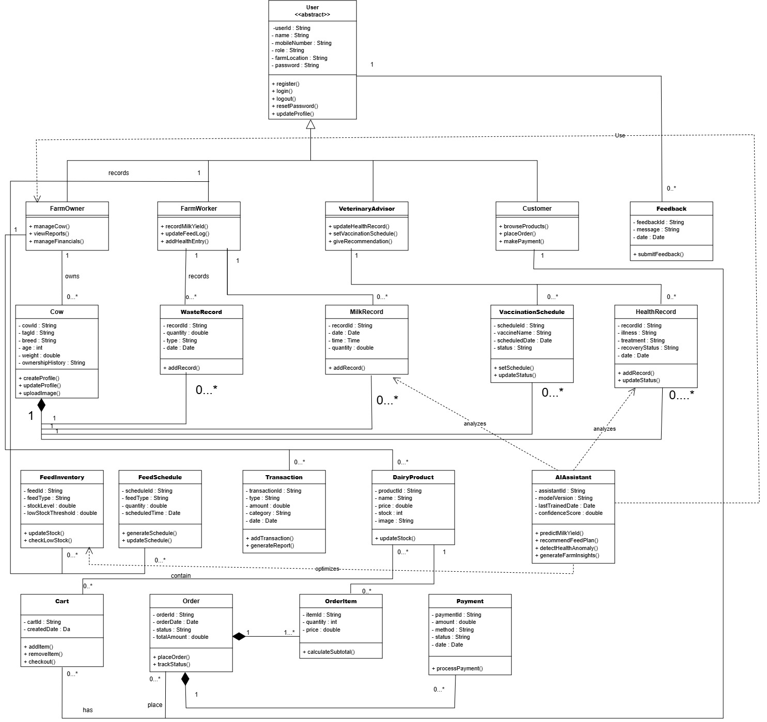

- Secquence Diagram

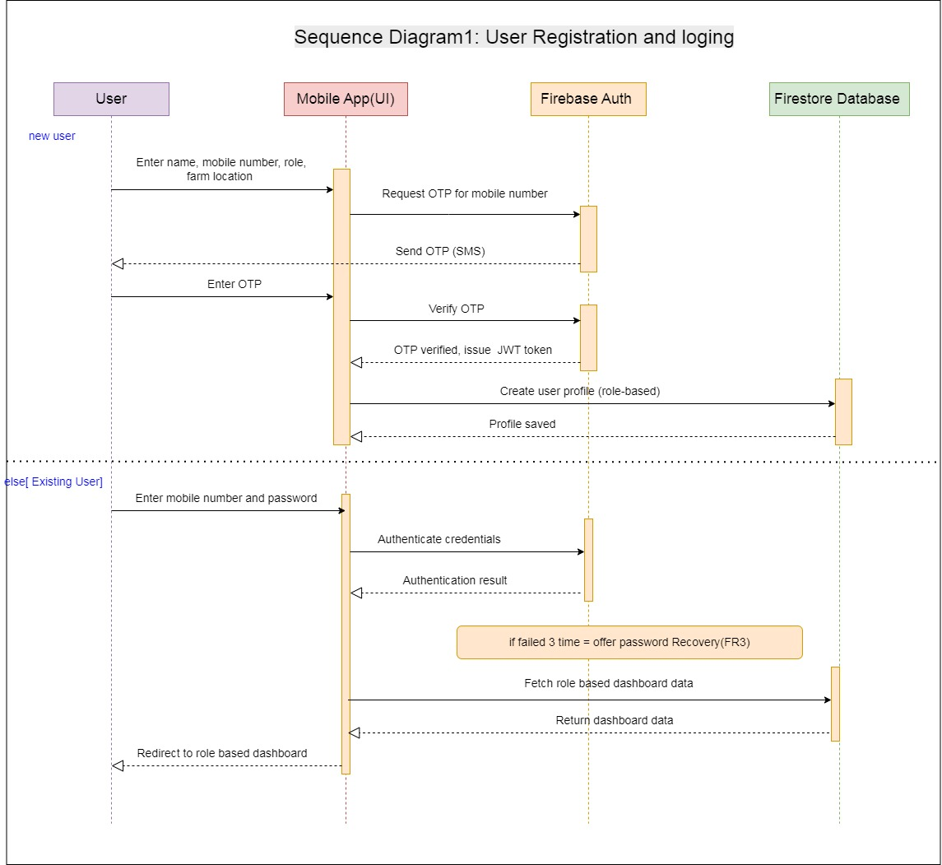

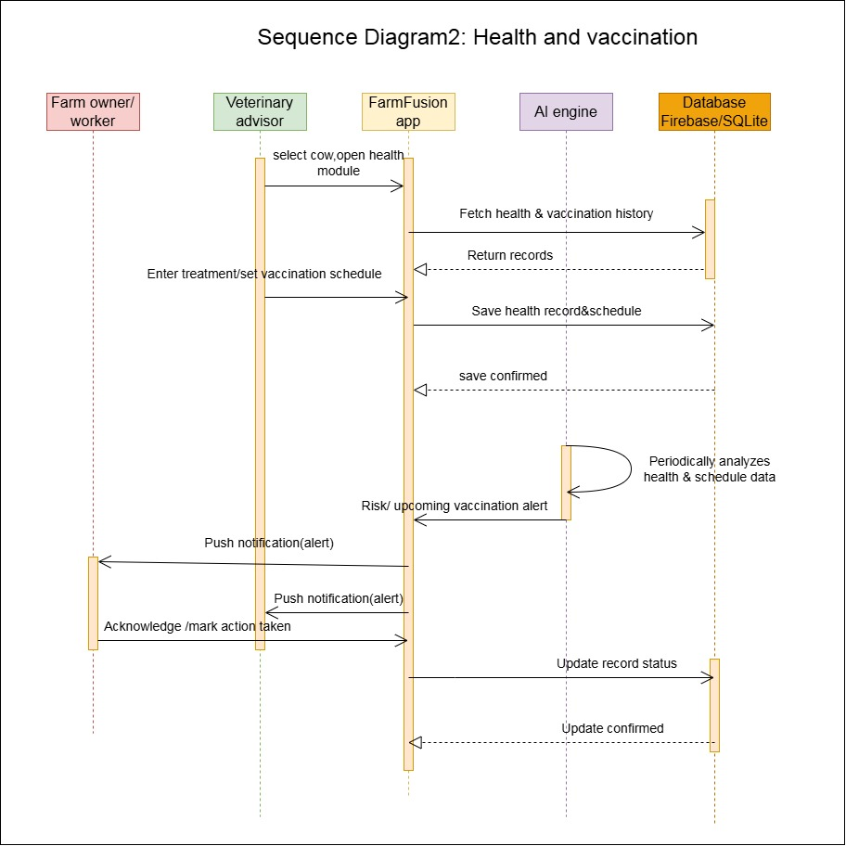

Secquence Diagram 3:Diary product menagement

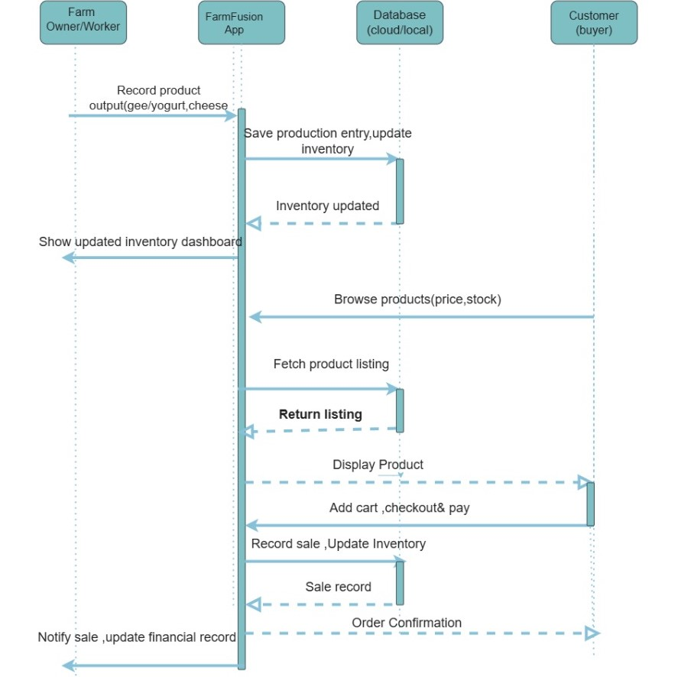
Secquence diagram 4 : milk record
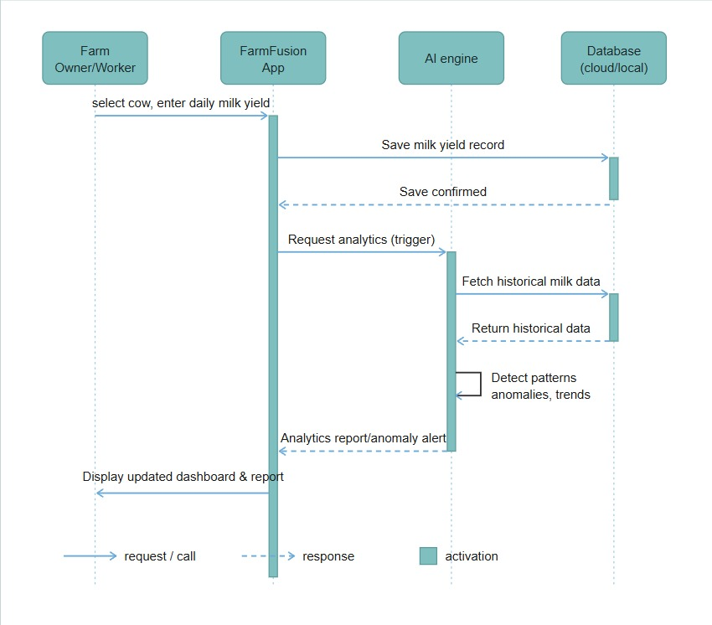

DFD ( Data Flow Diagram)

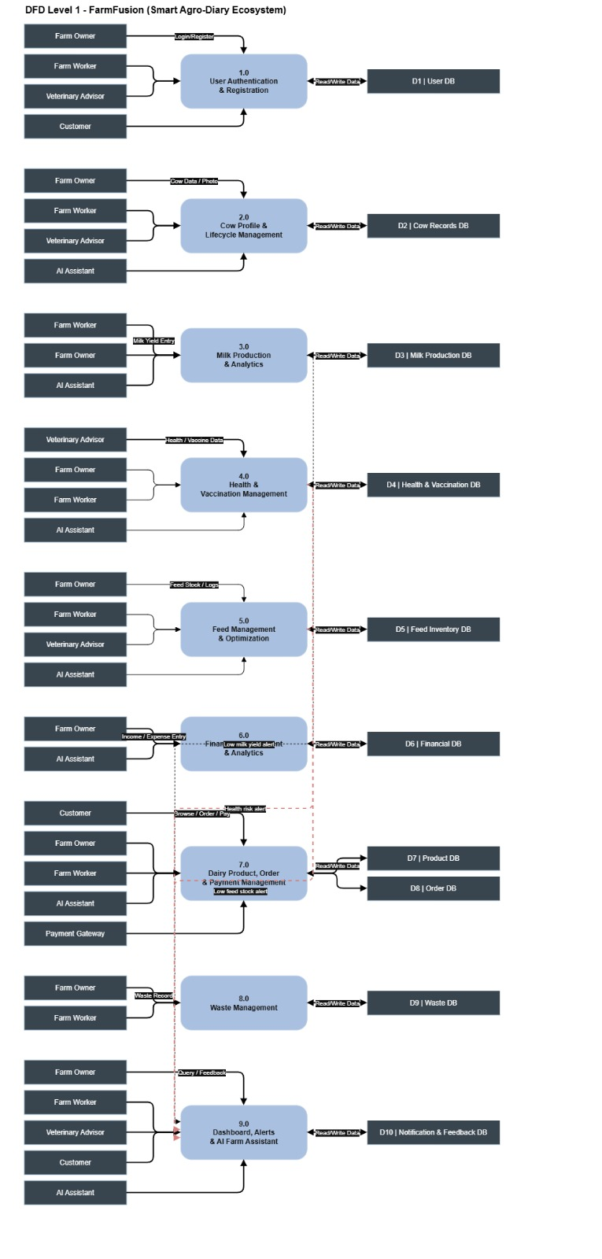

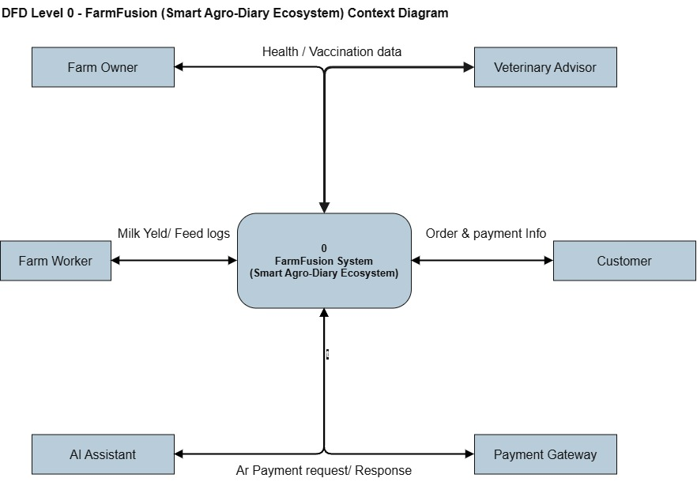

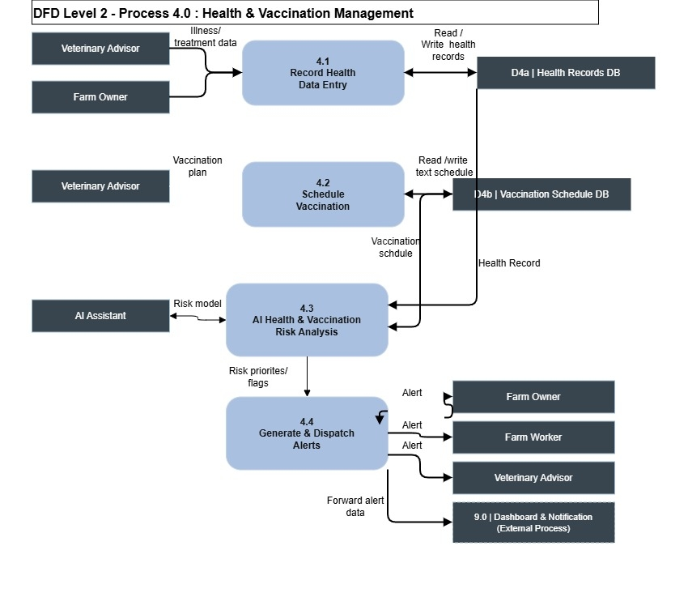

Pototype diagram

Link:https://sakibswe.github.io/farmfusion-prototype/

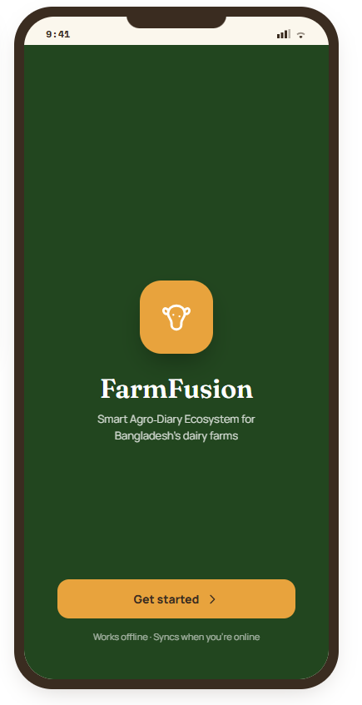

User loging page

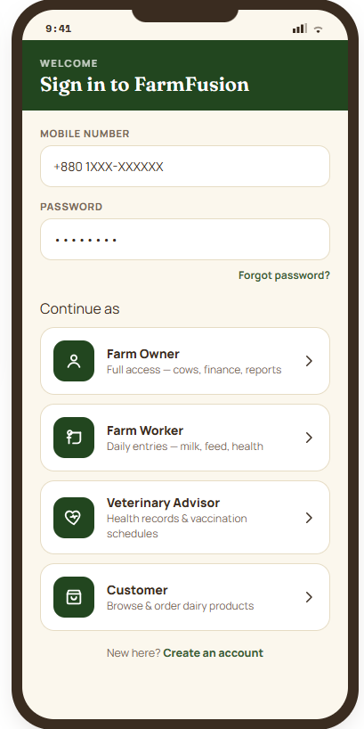

User Registration

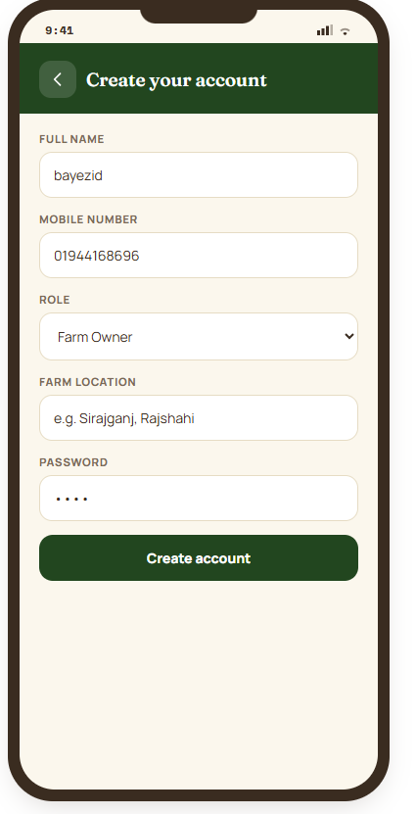

Farm owner dashbord

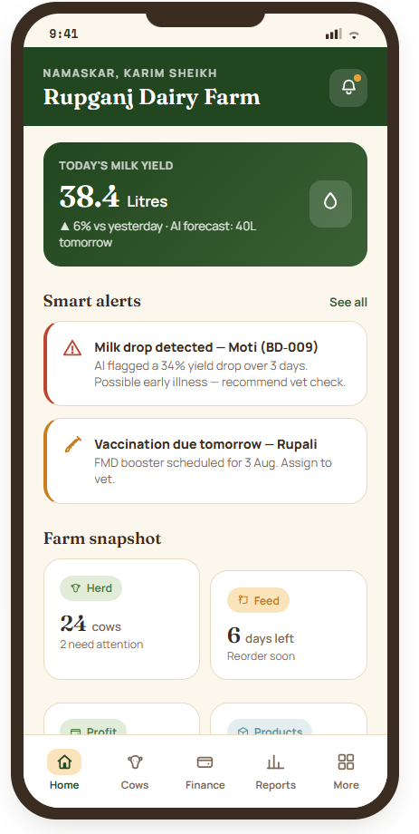

Cow record view by onwer side

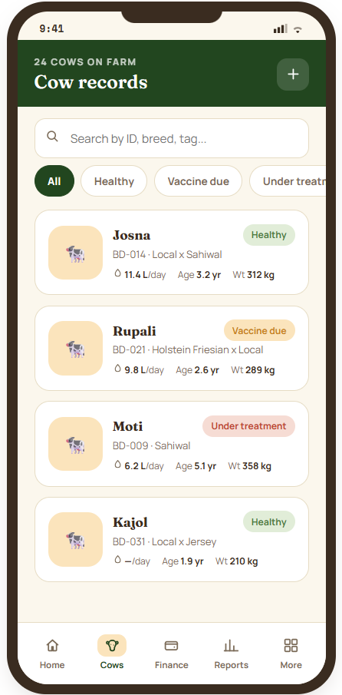

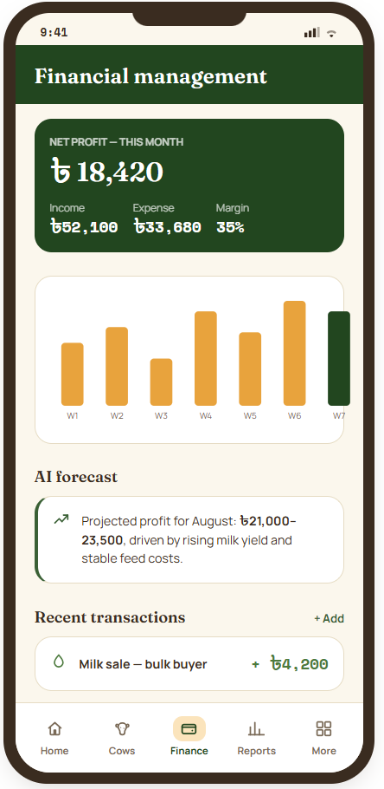

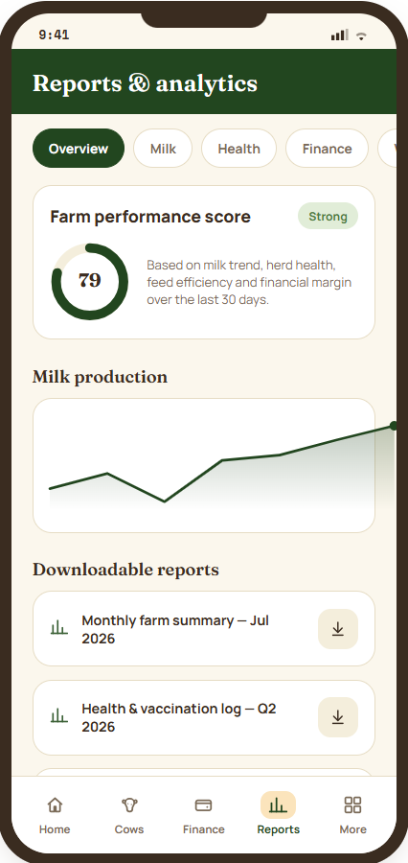

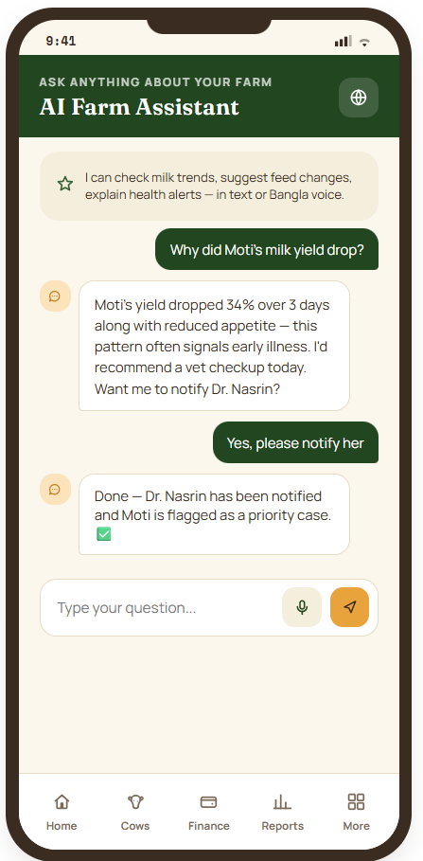

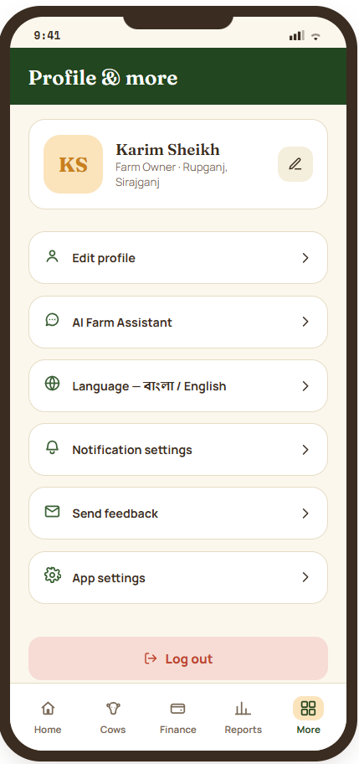

Worker dashbord

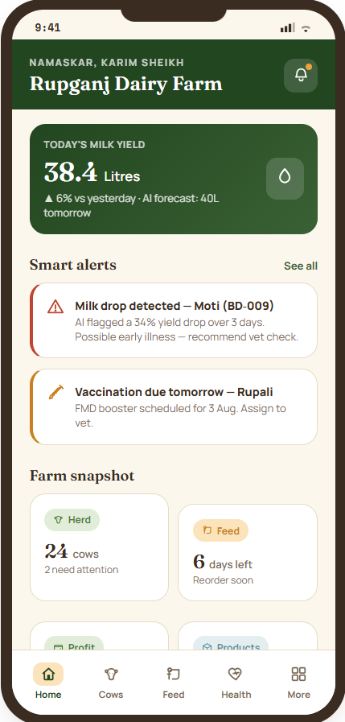

Add new cow by worker

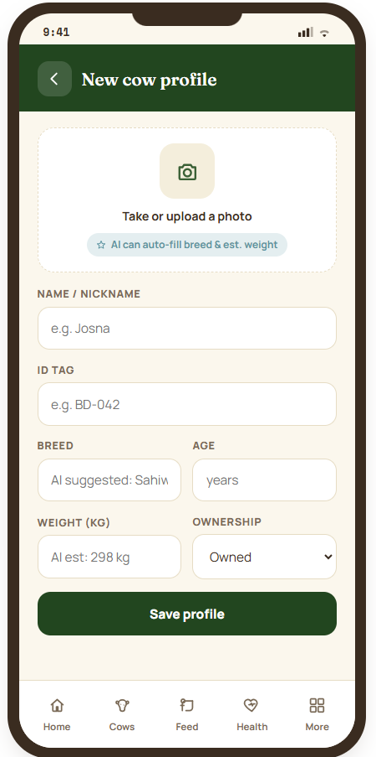

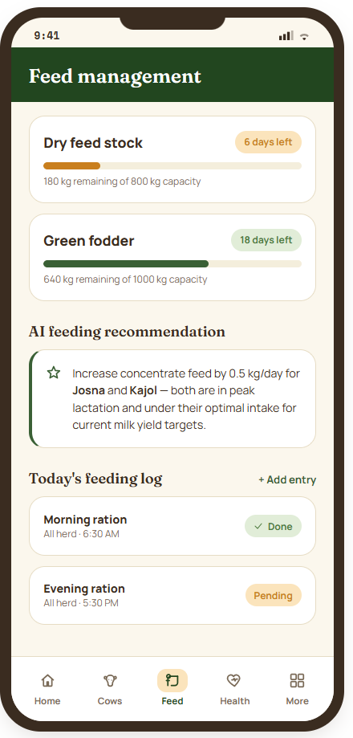

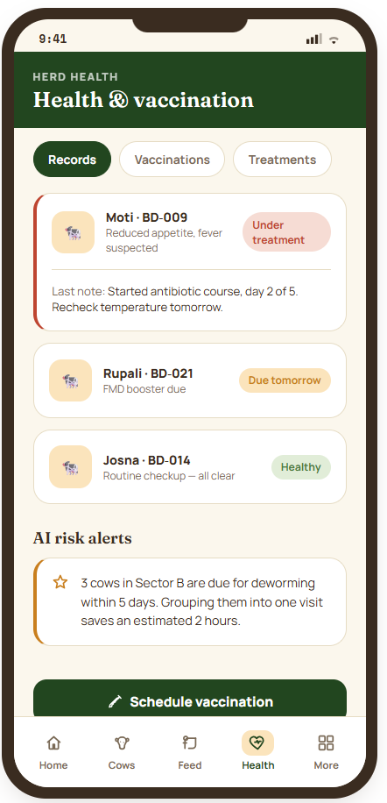

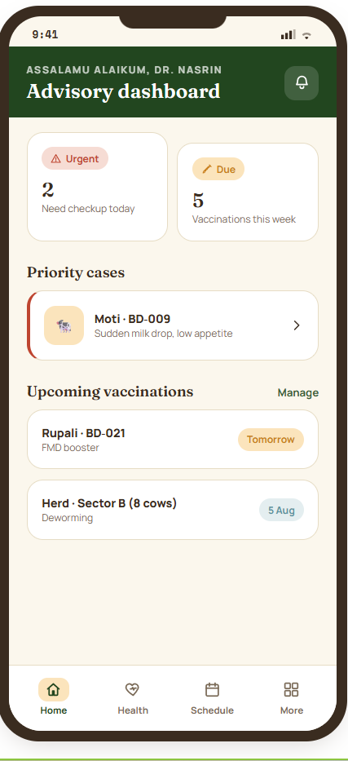

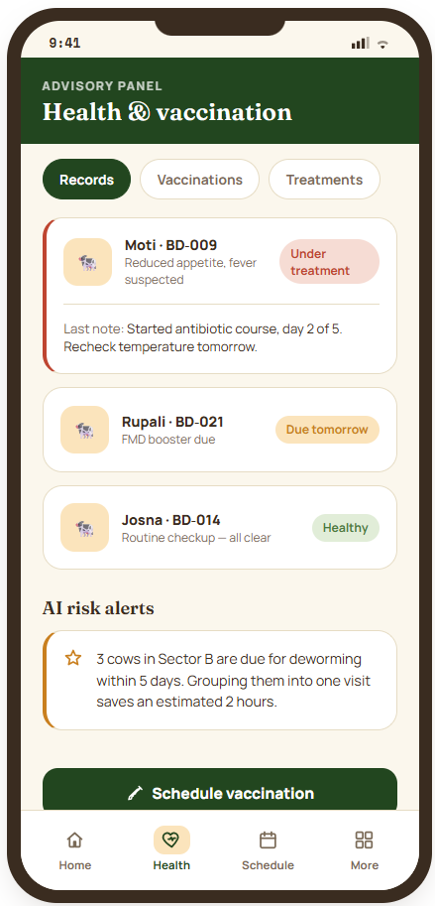

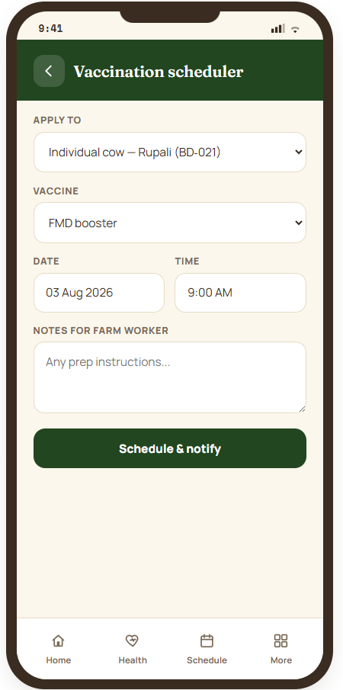

Customer dashbord

